The Terry Fox Story: Victory, not Victim

The story of Terry Fox is famous all over the world.
Terry was born in Winnipeg, Manitoba in 1958. He was a determined young athlete who hoped to become a Phys Ed teacher. That dream would never come true.
One day when he was 19, Terry came home with a pain in his right knee. It was cancer. To stop the spread of the cancer, doctors amputated his leg just above the knee. Terry soon learned how to use an artificial leg and was walking again in just three weeks. Later, he joined the national wheelchair basketball team.
In 1979, Terry began to run marathons. He used a new artificial leg made from a pogo stick and a shock absorber. Although Terry could not win against two-legged runners, he never gave up trying.
That fall, Terry came up with a plan. He was going to run across Canada to raise money for cancer research. His goal was to raise 23 million dollars - one dollar for every Canadian. On April 12, 1980, he began his “Marathon of Hope” in St. John’s, Newfoundland. Despite the pain, he was able to run between 30 and 50 kilometers each day.
By the end of June, when he got to Toronto, Terry’s “Marathon of Hope” was becoming a great success. A crowd of 10,000 people waited for him at Toronto City Hall. That day, alone, he raised $100,000 for cancer research.

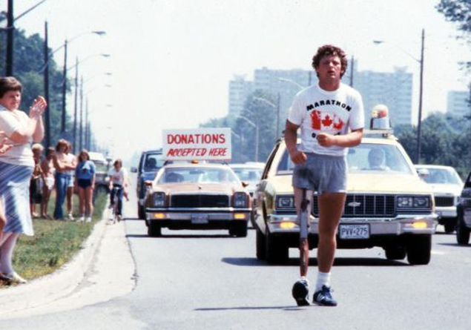

But when Terry reached Thunder Bay, the “Marathon of Hope” came to a sudden stop. The cancer had spread from his leg to his lungs. He had run 5,367 kilometers but he could run no more.
His parents took him home for treatment. By now he was receiving honors from all across the country. Even more important, he had reached his goal. Over 24 million dollars was raised for cancer research that year. Terry said, “People thought I was going through a nightmare, running all day long. But still I was doing what I wanted and a dream was coming true.”
Terry Fox died on June 28, 1981, at the age of 22. But his dream lives on. Each year since his death, Terry Fox runs have been held in 60 countries around the world. More than 500 million dollars has been raised for cancer research.
Terry Fox was a cancer victim. But his life was also a victory of determination and dreams. Someday, perhaps, his “Marathon of Hope” will give us the ultimate victory over cancer.

